- Aiken Trie

graph TD
ROOT((Root)) -->|c| C(C)
C -->|a| A(A)
A -->|r| R(R)
A -->|t| T(T)
ROOT -->|d| D(D)
D -->|o| O(O)
O -->|g| G(G)
ROOT -->|other| OTH((Others))
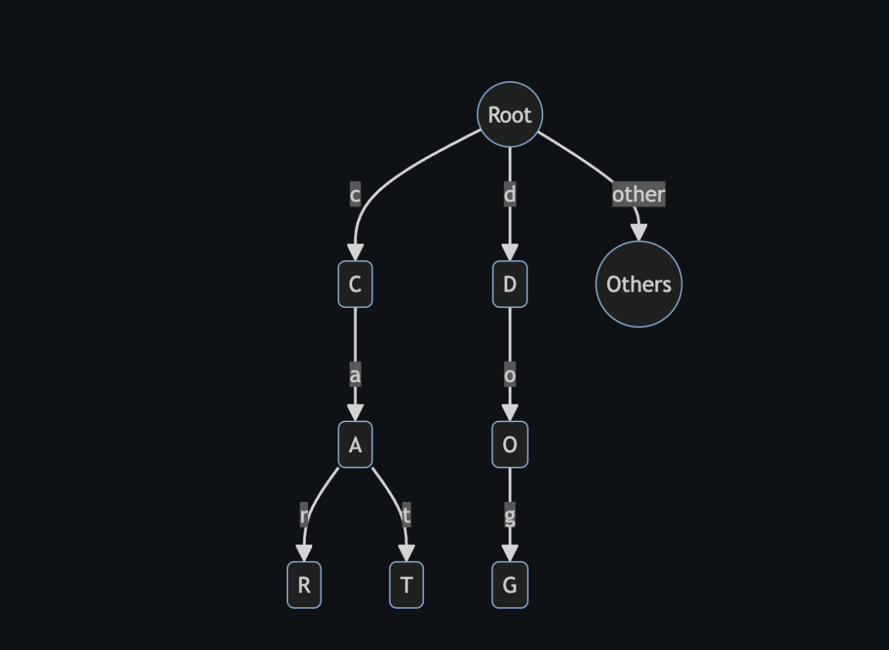

Test Result:

import { Emulator, Lucid } from "lucid-cardano";
import { defaultProtocolParams } from "./constants";
import { generateAccount } from "./utils";
import { trieScript } from "../src/const";
import {
appendTrie,
betweenTrie,
createTrie,
getTrieOrigin,
getUtxoByKey,
} from "../src";

console.log(`Trie Script Size: ${trieScript.script.length / 2}`);

describe("Synthetics", () => {
let emulator: Emulator;
let lucid: Lucid;
let trieAddress: string;
let trieRewardAddress: string;
beforeEach(async () => {
emulator = new Emulator([]);
lucid = await Lucid.new(emulator);
trieAddress = lucid.utils.validatorToAddress(trieScript);
trieRewardAddress = lucid.utils.validatorToRewardAddress(trieScript);

const TRIE_USER = await generateAccount({
lovelace: BigInt(100000000000000000),
});

emulator = new Emulator([TRIE_USER], defaultProtocolParams);
emulator.chain[trieRewardAddress] = {
registeredStake: true,
delegation: { rewards: BigInt(0), poolId: "" },
};
lucid = await Lucid.new(emulator);
lucid.selectWalletFromPrivateKey(TRIE_USER.privateKey);
});

it("Should pass e2e on creation, two insertions", async () => {
let trie = await createTrie(lucid, trieAddress, trieRewardAddress);
emulator.awaitBlock(1);
let trieOrigin = await getTrieOrigin(lucid, trie.trieUnit, trieAddress);
let trieUtxo = await getUtxoByKey(lucid, trie.trieUnit, "", trieAddress);
await appendTrie(
lucid,
trie.trieUnit,
trieOrigin!,
trieUtxo!,
"hello_world",
trieAddress,
trieRewardAddress,
);
emulator.awaitBlock(1);
let newTrieUtxo = await getUtxoByKey(lucid, trie.trieUnit, "", trieAddress);
await betweenTrie(
lucid,
trie.trieUnit,
trieOrigin!,
newTrieUtxo!,
"hello",
trieAddress,
trieRewardAddress,
);
});

it("Should fail on duplicate insertion (1)", async () => {
let trie = await createTrie(lucid, trieAddress, trieRewardAddress);
emulator.awaitBlock(1);
let trieOrigin = await getTrieOrigin(lucid, trie.trieUnit, trieAddress);
let trieUtxo = await getUtxoByKey(lucid, trie.trieUnit, "", trieAddress);
await appendTrie(
lucid,
trie.trieUnit,
trieOrigin!,
trieUtxo!,
"hello_world",
trieAddress,
trieRewardAddress,
);
emulator.awaitBlock(1);
let newTrieUtxo = await getUtxoByKey(lucid, trie.trieUnit, "", trieAddress);
betweenTrie(
lucid,
trie.trieUnit,
trieOrigin!,
newTrieUtxo!,
"hello_world",
trieAddress,
trieRewardAddress,
)
.then(() => {
throw "This should have failed";
})
.catch(() => {
// failure successful
});
});

it("Should fail on duplicate insertion (2)", async () => {
let trie = await createTrie(lucid, trieAddress, trieRewardAddress);
emulator.awaitBlock(1);
let trieOrigin = await getTrieOrigin(lucid, trie.trieUnit, trieAddress);
let trieUtxo = await getUtxoByKey(lucid, trie.trieUnit, "", trieAddress);
await appendTrie(
lucid,
trie.trieUnit,
trieOrigin!,
trieUtxo!,
"hello_world",
trieAddress,
trieRewardAddress,
);
emulator.awaitBlock(1);
let newTrieUtxo = await getUtxoByKey(lucid, trie.trieUnit, "", trieAddress);
betweenTrie(
lucid,
trie.trieUnit,
trieOrigin!,
newTrieUtxo!,
"hello_world",
trieAddress,
trieRewardAddress,
)
.then(() => {
throw "This should have failed";
})
.catch(() => {
// failure successful
});
});
});

